Name: Ethan Becker
Student ID: ebecke10
Date: 11/7/25

Instructions: You should have one page (1 html file and 1 css file) of your site completed by the time you submit this. Use the following to have a written discussion about the current progress of your website. After answering the questions below, insert a screenshot of the index.html file's browser view that you have completed so far (remember, you should have one page’s browser view and a CSS file). Do NOT screenshot the HTML code, as we can’t run the code. Save the file to yourasurite – Project Assignment – Project Update 1.docx file and yourasurite – Project Assignment – Project Update 1.pdf file. Submit both files to Canvas.

- How do you feel your website is coming along? (10 points)

I’m extremely happy with the progress thus far! Already I feel that my website is clearly presenting my portfolio in a very professional way, it’s been a wonderful experience to revisit some of my early work!

- What issues have you encountered on your first few pages? (4 points) How did you fix those issues, if you did? (3 points) Are there any issues still unresolved? (3 points)

The biggest issue I’ve faced so far is making everything fit together *just right*. You’ll see in the portfolio.css file but the rules for the cards alone are more than half of the file! I ended up completely starting over at one point because I felt there was just TOO much going on and it was overwhelming me. However, after lots of trial and error, and finding the right rules to use, I think they fit my vision! Theres still a weird issue with the top cards in the grid where they clip through the credits heading.

- Tables are useful when you need to display data in an organized and structured format, such as schedules, pricing lists, or comparison charts. They help improve readability and allow users to quickly interpret information. Describe in which page you would like to use a table on your website (2 point) and what info will be included in that table (8 points). Please note: A table needs to have at least a header row + at least three data rows + at least three columns.

As of right now, I have a table on my landing page, I’m currently using it to display my experience levels with different game engines, but I might want to expand this to more engines, or skills (git hub, other relevant programming languages etc.) However, I might want to find a different way to convey this information later, so for now I at least have the table for this assignment set up. I might use another table in my canvas kingdoms credit section to talk about the different character movement states instead, as there’s a lot to cover, and I used a table in my game design document!

- Where would you like to use a form on your website? (2 points) What will the form be used for? (2 points) Draw a simple sketch of how it will look (what fields will be included, any basic styling, etc.) and paste it below: (6 points) Please note: A form should have at least 4 fields

I would really like to have a forum linked in the footer and the header, that I could use to get feedback on my portfolio. I would really like to get feedback on the impression I’m leaving with my site.

How would you rate the professionalism of this website

Would you say this site makes you more or less likely to reach out to me?

What Project did you find the most impressive? Group of Answer Choices

What Project did you find the least impressive? Group of Answer Choices

- List your project website's GitHub URL. (10 points)

https://github.com/d3bSt3p/Web-Portfolio

- After doing several pages, has your sitemap changed? If so, revise your previous sitemap and insert it below: (10 points).

My site map has changed a lot, I think it’s much more straightforward now!

Index
Inferno
Canvas Kingdoms
Fishy Business
Picturegeist

- Insert the latest wireframe below: (10 points)

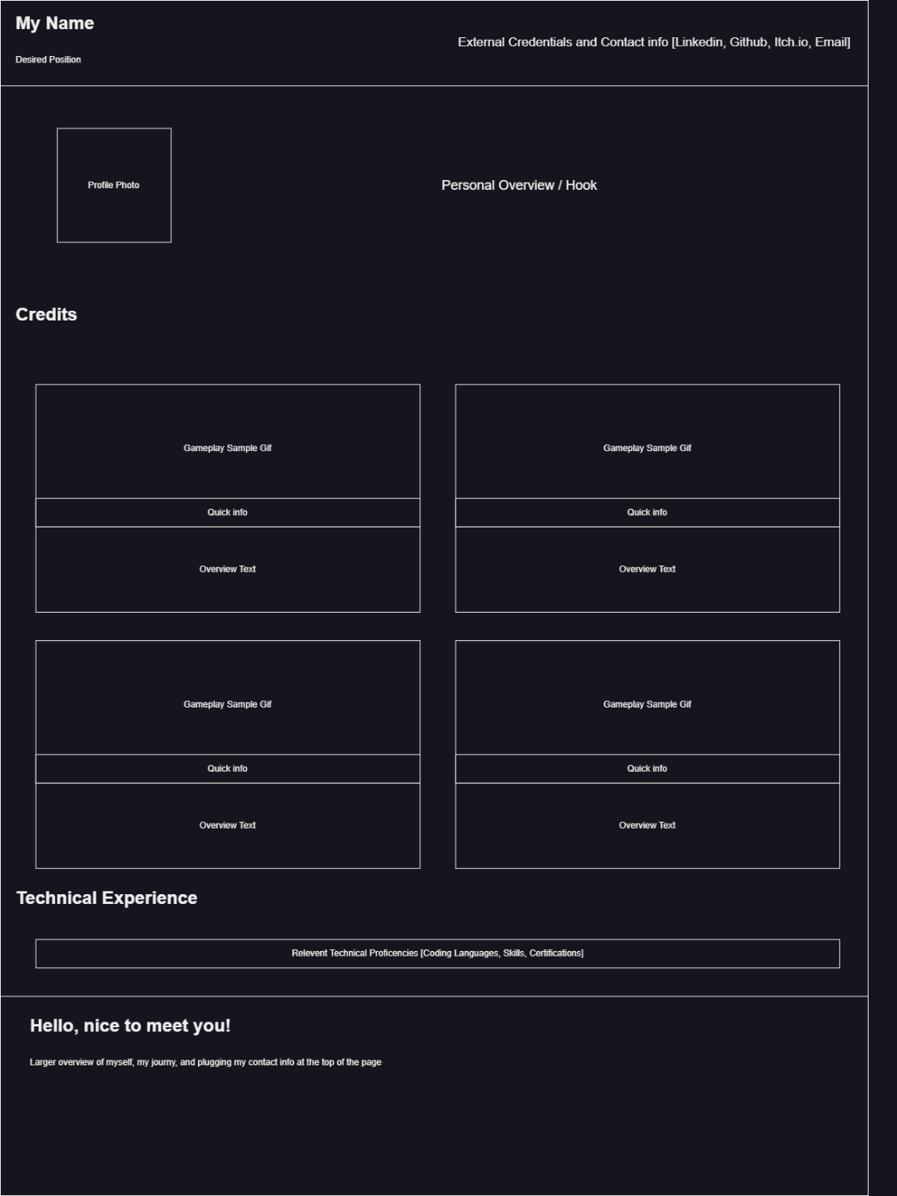

Web page browser view screenshot of Page #1 (15 points) 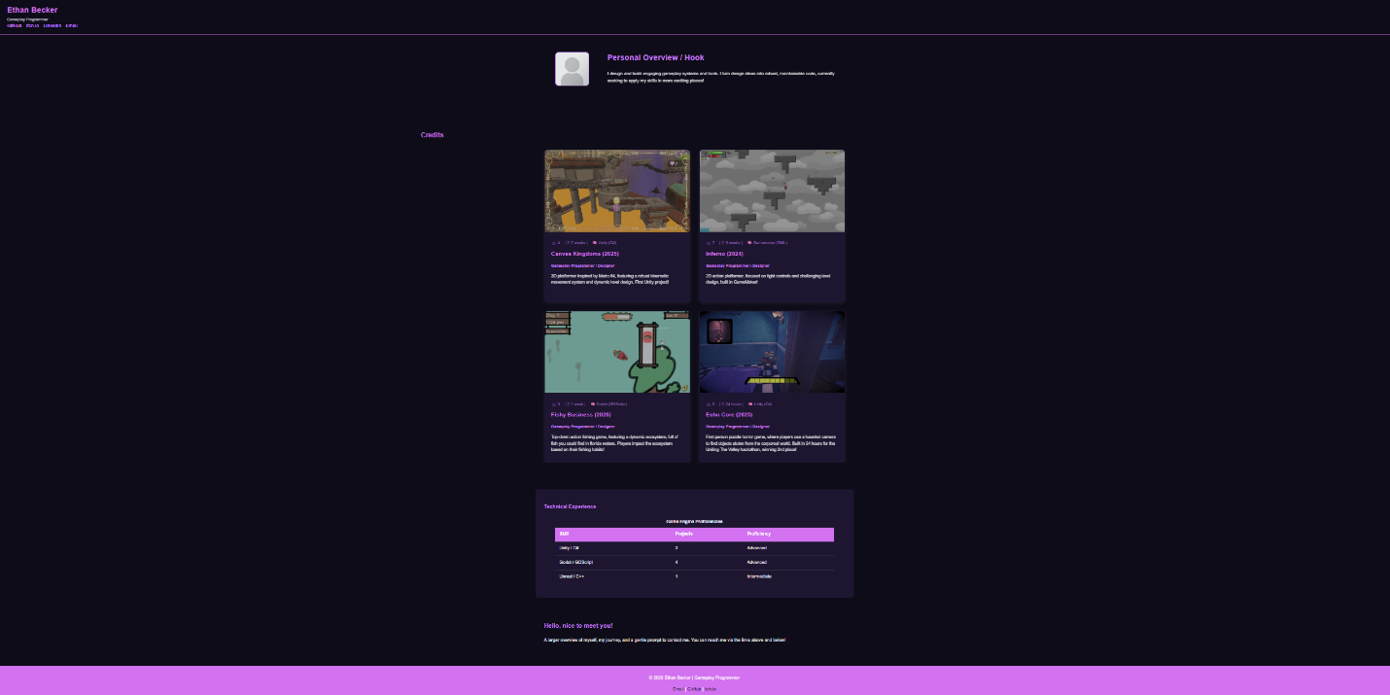

Screenshot of CSS file
Should include at least 5 selectors and 15 properties (15 points, 1 point for each)

